

DevOps Lead Assessment Test

* As your company needs their API products to have production/non-production in AWS Cloud, there are some requirements for the infrastructure that need to fulfill by you as a DevOps with details:
* The APIs consist of 4 application services that will communicate with each other internally and externally, and each service will serve high traffic

requests.

* The need for a PostgreSQL database that can be connected to 4 APIs application services and from the outside.
* The requirement to have static Public IP for the outbound traffic.
* Application and server monitoring; for this, please give an explanation about what needs to be monitored/logged for the application and for the

infrastructure.

**Questions:**

* Create a High Availability infrastructure design/diagram that fulfills all of the requirements mentioned above, and provide a clear explanation of how the architecture works.
* Provide details of EC2 specs so the APIs service is able to handle 10,000 average concurrent requests per minute, also the APIs service should be able to handle significant traffic increment (max: 100.000 requests per minute) for the production environment and also suggest EC2 specs for the

non-production environment (dev and staging).

* Provide centralized application and server monitoring, feel free to use any other monitoring tools; ex: newrelic, datadogs, etc with an explanation of why the tools are suitable to use as the monitoring tools.

**Answare**

1. **Diagram**

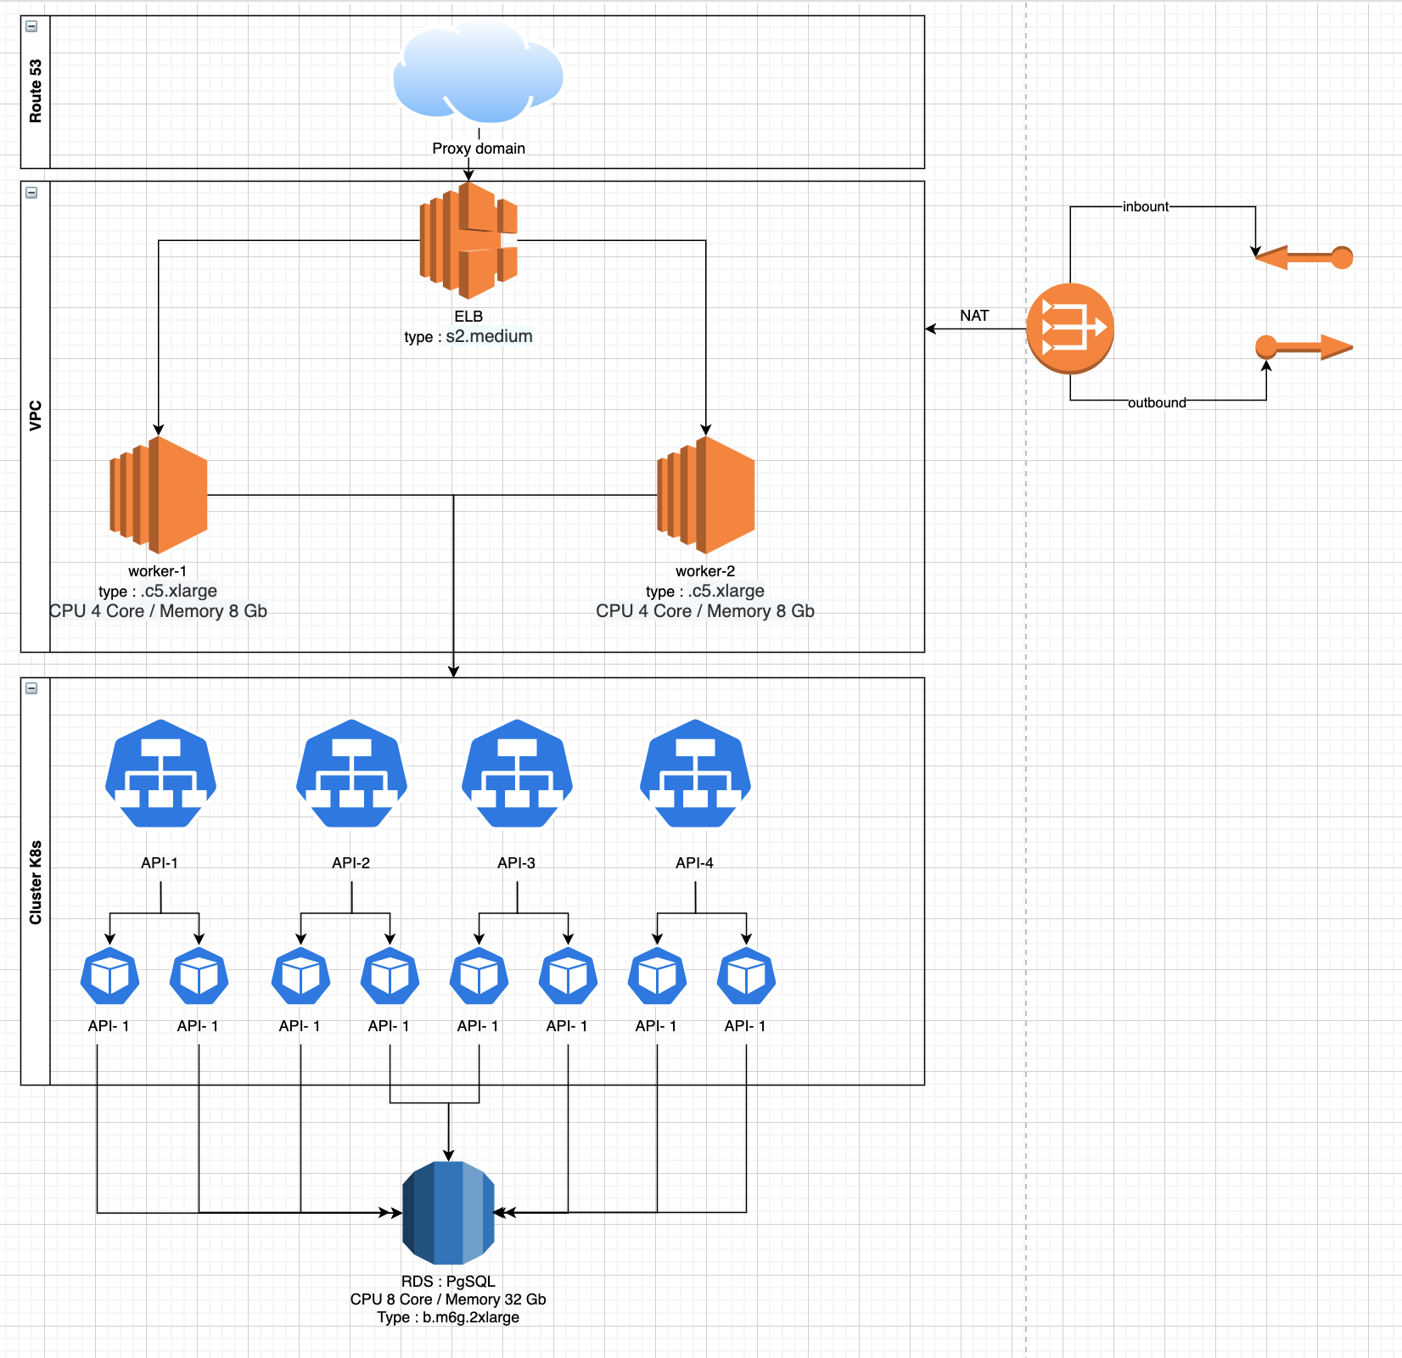

1. **Mimum handle 10.000 concurent request per minute**

**Answare :**

Minimum EC2 4/8 for the server, for example im test for use hit simple backend use k6s single request use a 2/4 for server and average for concurrent user 5000 per minute

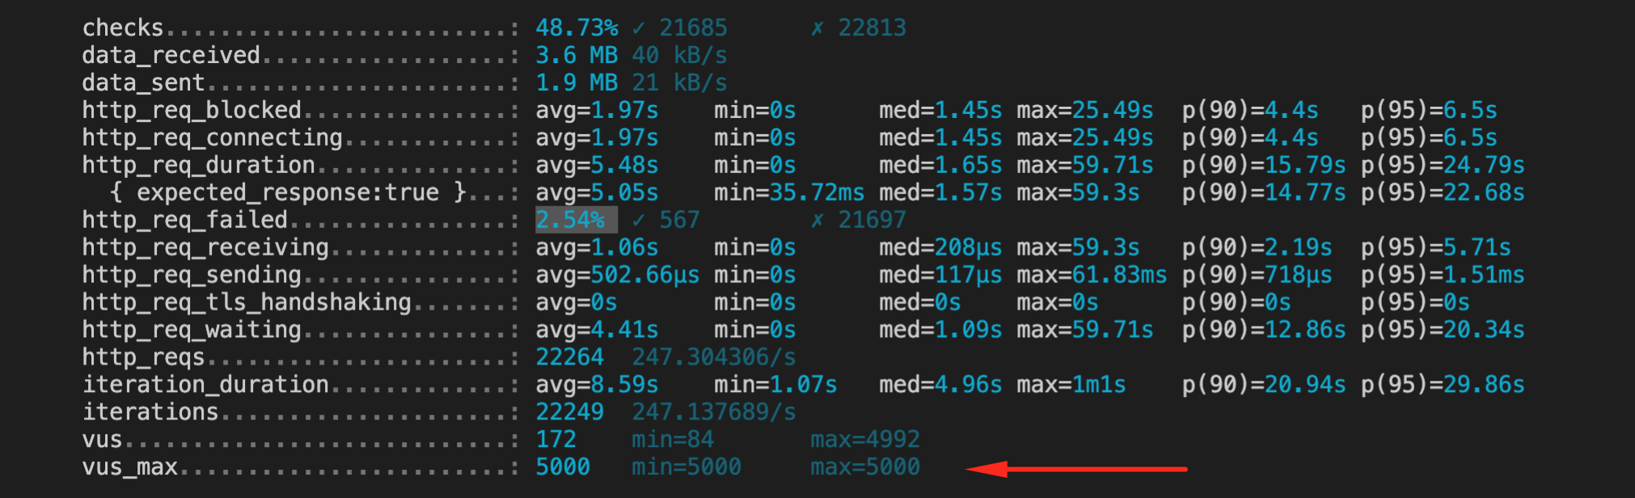

1. **Centralized apps and monitoring.**

**Answare :**

For monitoring application use newrelic, because is very simple for use and the feature is complete, but the service need lisence